PRESS KIT

My Home- Your War

DOCUMENTARY, 52 min

Written, Directed & Co-Produced
by Kylie Grey

© 2006

Kylie Grey &

Denoux Films Productions
All Rights Reserved

DENOUX FILMS PRODUCTIONS
Executive Producer:
Chantal Denoux
PO Box 1100
Paradise Point
Qld Australia 4216
WWW.denouxfilms.net
CD@denouxfilms.net
+61 419 808808

Summary

Page

- Preview DVD and Electronic Press Kit

- Poster of the Film, Awards & Screenings

- Short Synopsis

- Extended Synopsis

- Biography of the Director Kylie Grey

- Filmography of the Director (1)

- Filmography of the Director (2)

- Director’s Notes (1)

- Director’s Notes (2)

- Biography of Executive Producer Chantal Denoux

- Biography of Co-Producer Marcus Gillezeau

- Credits List (1)

- Credits List (2)

- Credits List (3)

- Stills of the Film

- Stills of the Film

- Technical Information

- Primary Contact:

Executive Producer Chantal Denoux

Preview DVD and Electronic Press Kit

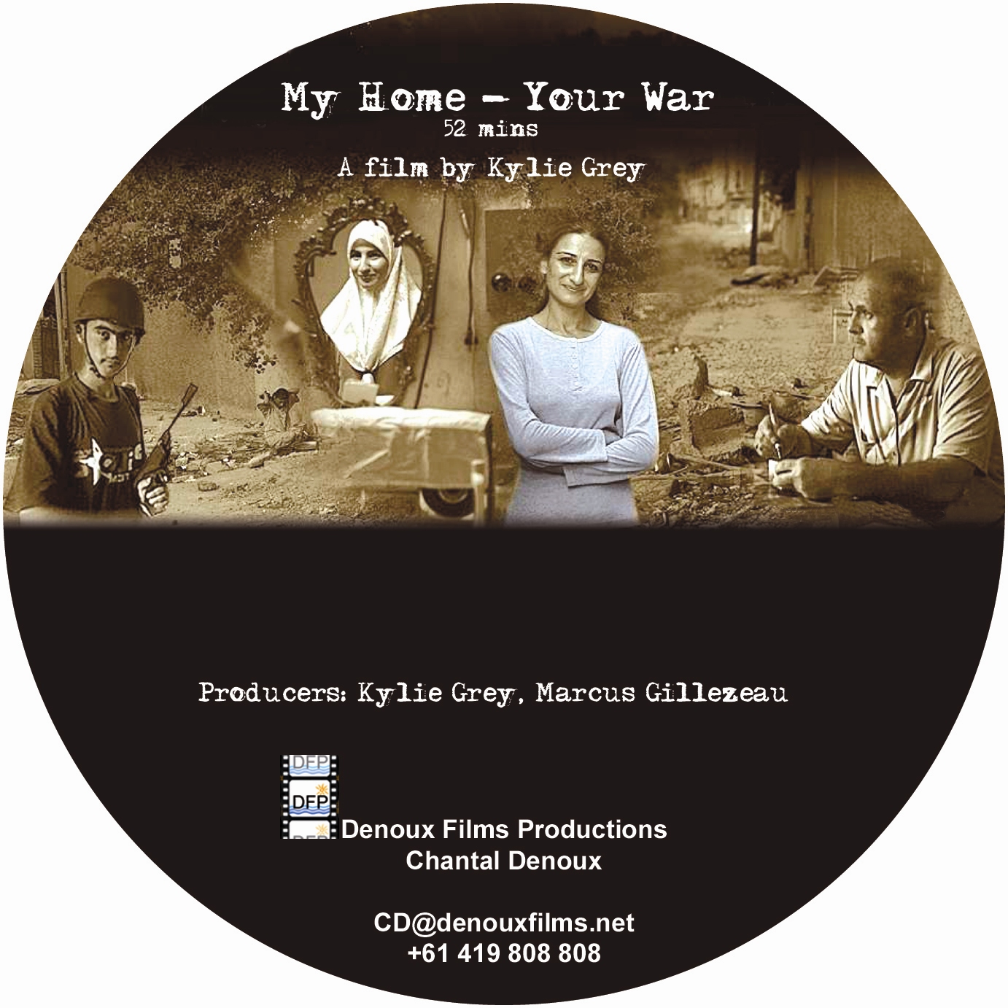

Electronic Press Kit

Poster of the Film, Awards and Screenings

My Home- Your War

- Winner of the Gold World Medal for Best Documentary in New York,
2nd Feb 2007
- Winner of the Australian TV Atom awards for Best Documentary –Social &
Political Issues, 19 Oct 2007
- Winner Australian TV Atom awards for Best Documentary – Human Story,
19 Oct 2007
- Selected & Screened in Women International Film Festival in Seoul, Korea ,
5 & 9 April 2007
- Selected & Screened in Global Peace Film Festival in Florida, USA, 29 Sept 2007
- Scored excellent audience rates during its screening on SBS TV, 3 April 2007

Coming Soon in November

- Screening in WT Os International Film Festival in Oslo, Norway
- Screening in London Frontline Club, London, UK
Other Screenings in Dec TBC…

Short Synopsis

Shot in Baghdad over three years, before, during and after the Coalition attack on Iraq,
MY HOME-YOUR WAR takes us inside the home of an Iraqi family as they deal with the disruptions and terror of war as it affects their daily lives. Meet Layla, her shy teenager son who she suspects is working with the anti-US resistance, her workaholic husband and her starry eyed sister .This film is not only a historical document of the Middle East, it is a personal account of how these changing times are playing out in Arab women’s lives, and how Iraqi women have become the first casualties of democracy denied.

Keywords
- My Home- Your war
- Terror of War
- Layla, a bagdad woman
- Sunni Muslim family
- Iraq, before,during and after the coalition attack

Extended Synopsis MY HOME-YOUR WAR

Shot in Baghdad over three years – before, during and after the Coalition attack on Iraq, My Home – Your War takes us inside the home of an Iraqi family as they deal with the disruptions and terrors of war as it affects their daily lives.

Layla Hasan, 40, husband Yasir and teenage son, Amro live in the district of Adhamiya, the heartland of Sunni Muslim resistance against US forces in Baghdad. Layla is a middle class Iraqi woman. Striking and intelligent, Layla speaks four languages, she had little choice when she was hand-picked to work as a translator for Saddam’s regime. When the US forces arrived she hoped they might offer a path to freedom.

Yet now the war is testing her most intimate relationships.

Meet her shy teenage son who she suspects is working with the anti-US resistance; her steady but workaholic husband: and her once radical sister who is becoming increasingly conservative and religious as the chaos of Baghdad fuels her insecurities. Layla, herself, becomes more personally isolated as the war progresses and she dreams of escaping to another country.
The hallmarks of the turbulent years in Baghdad, the invasion, the looting, the capture of Saddam, the Abu Ghraib Prison scandal, and the beheadings of foreigners by Islamic militants are images that are familiar to viewers across the world.

In this film we see these events from a different perspective, from the inside, from the point of view of a Sunni Muslim family living through them. Layla and her family give a revealing insight into the contrasting ways war and regime change strain close relationships, nurture extremism and change a family’s destiny.

My Home – Your War is not only a historical document of an important time in the history of the Middle East. It is a personal account of how these changing times are playing out in Arab women’s lives, and how Iraqi women have become the first casualties of democracy denied.

Biography of Director Kylie Grey

KYLIE GREY 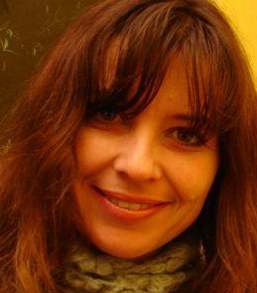
Filmmaker

Kylie started her working life has a radio journalist at the age of 19 and has been making films about human rights and social issues for the past seven years.
Her work as a journalist has taken her to Iraq, Bangladesh, and Argentina, The Philippines, Romania, Mozambique, East Timor, Sri Lanka and many more of the world’s flashpoints.
Her first film, Child Prisoners in the Philippines has been screened around the world and was official selection at the Ghangzou Documentary festival in China in 2004.
Her film on Child trafficking – Camel Jockeys in the Middle East screened on ABC Television Australia and was subsequently awarded the gold world medal in the social issues category at the 2004 New York Film Festival.

For the past three years, she has been following the life of Layla Hassan, a Baghdad woman and her family during the conflict in Iraq. The film, My Home Your War just won the world Gold Medal in New York Film Festival 2007 .Her 52min documentary was screend on SBS Television Australia in April 2007 on SBS’s Cutting Edge program to rave reviews and excellent ratings. The film has subsequently won Best Documentary (Human Story) and Best Documentary (Social and Political issues) at Australia’s ATOM awards in October 2007. My Home Your War has been screened at filmed festivals in Asia and the U.S.

Kylie holds a Bachelor of Arts in Media and Communications and a Masters degree in Social Science. She is passionate about using the medium of film to give audiences in the Western world an insight into the lives, hearts and minds of people in the developing world.

Kylie currently works for Aljazeera English television as a producer and reporter where she is making news feature stories in the developing world. Her story on Agent Orange Children in Vietnam is a finalist in the 2007 Asia Awards for best single news report.

KYLIE GREY
17/67 Bayswater Road
Kings Cross NSW 2011 Australia
Tel: +601 2906 4317 / +61 2 9331 2317
kyliegrey1969@yahoo.com.au

Filmography of Director Kylie Grey (1)

Layla – My Home Your War
One hour documentary shot in Baghdad before, during and after the War.
Director/Writer/Co-producer
Sold to SBS Television
Won theGold World Medal in New York Film Festival 2007
Won Best Documentary (Human Story) Best Documentary (Social and Political issues) ATOM Awards Australia 2007
Selected in Human Rights Film Festivals

Agent Orange – Vietnam
News feature story on the plight of Agent Orange children in Vietnam
Reporter
Aljazeera English
Finalist Asia Awards 2007 – Best single news report

Tamil girl – Sri Lanka
News feature story on the frontline with the Tamil Tiger’s formidable female fighting force
Reporter/camera
Aljazeera English

Cartoneros – Lives of Buenos Aires Slum dwellers
Dateline, SBS Television (in production)
Reporter/Producer/Camera
Location: Argentina

Maternal Health Educational Video
Filmed, and Produced a 26 minute Video for Kirsty Sword Gusmao’s Alola Foundation in East Timor
Location: East Timor

Maradona’s Comeback
Producer/Camera
Fox Sports (in production)
Location: Argentina

Raul the Terrible - Argentina
One hour documentary on the life and times of Argentina’s Picqueteros
Director’s Assistant
Sold to SBS Television
Best direction (Documentary) Australian Film Institute 2006

Filmography of Director Kylie Grey (2)

Streets of Baghdad
Dateline, SBS Television March 2003
Reporter/Producer
Location: Iraq

Camel Jockeys – Child Trafficking in the Middle East
Foreign Correspondent, ABC TV November 2002
Producer/Researcher
Location: Bangladesh and UAE
Awarded Gold Medal at the New York Film Festival Social Issues category 2004

Child Prisoners in the Philippines
Foreign Correspondent, ABC TV April 2002
Reporter/Producer
Location: Philippines
Official Selection Ghangzou International Documentary Festival, China 2004

CONTACT Kylie Grey Email: kyliegrey1969@yahoo.com.au Tel: +6012 906 4317

Director’s Notes (1)

My creative vision in My Home-Your War was to intimately portray the experience of those most invisible in the media spectacle of modern warfare – the women and families who, so often, are the most affected. Shot over three years ago, during and after the US invasion of Baghdad, the film takes us inside the home of an Iraqi family as they deal with the disruptions and terrors of war as it impinges on their daily lives.
As a westerner consuming the media coverage on the war, the impression given was that this would be a clean, quick war which would improve the lives of the Iraqi people. This did not ring true so I decided the best way to really get a sense of the dramatic changes a war was going to have on the lives of those living through it was to hear the voices of the people themselves by spending time with a family as these events unfolded.
I met Layla at a conference in Baghdad three weeks before the war in Iraq. We liked each other immediately and she agreed at great personal risk to be filmed at home with her family. We became firm friends and the closeness we shared gave me incredible access to Layla’s fears, dreams and secrets, which I believe gives the film an unusual strength and intimacy.
After my first trip to Baghdad, Layla and I stayed in contact throughout the war. When The Australian Film Commission came to the party with development money, I returned to Iraq to continue filming Layla in newly occupied Iraq.
As Baghdad changed during the Occupation and violence escalated, we were able to get an insight into the changing relationships with her own family.
We returned to Australia with hours of amazing footage and applied for the AFC production funds, but were short listed and knocked back three times! With no money to go on, it was tempting to just give up until a reprieve came in the form of an SBS pre-sale acquisition.
This was enough money to buy a digital camera and send it back to Layla so she could continue to film her own life. Layla spent the next couple of years filming her daily life as the war unfolded and then sending the tapes back to Australia. The footage a sort of “video diary” became a revealing document of her spiritual demise as the war progressed and of her teenage son, Amro’s increasing involvement with the growing insurgency in the country.
Having exhausted all funding avenues for the film, I wondered how I was going to pay for the post production and get it broadcast. Then I met Chantal Denoux. We bumped into each other at a Women in Film and Television night. She asked for a copy of the pilot. The next day she rang and said she would provide the money required to finish the film. Chantal was true to her word and the following year after a four month edit (a gruelling but delightful creative journey with one of Australia’s most talented young editors) My Home Your War was finished!

Director’s Notes (2)
The documentary, My Home-Your War, although driven by me, has come to fruition because of the support of people who believed in this film: David Opitz, who took a risk to come with me to Iraq before the war. Marcus Gillezeau (Producer) who encouraged me and gave me great advice, as well as overseeing the online and the documentary’s final journey to air. Chantal Denoux, (Executive Producer) who supported me and the film financially and spiritually. Max Bourke whose brilliant camera work helped us to record the fantastic footage in the film. Matt Walker who put his talent and long hours towards the editing. Barton Staggs who brought his passion towards the music. Kim Hopwood who did the brilliant graphics and Jerry Rickard who has spent hours as sound recordist and much more.
To conclude, I believe My Home-Your War is unique in many ways. It is a unique and timeless look at a family living amidst war. It is intensely personal because of my close friendship to Layla who risked her life to tell her story.
The three year shoot allows the audience to see the changes in the characters over time and how war affects their daily lives. Finally, the film is unique because it integrates letters, emails, phone conversations and home video shot by the family themselves.
Layla’s journey through war unfolds against the backdrop of a city in crisis. Through a mother’s pain, her hopes, her dreams, her fears and regrets, I have understood more of war and its affect on a family life than a lifetime of news coverage could convey. I wish to pass this on
My journey as a filmmaker through this film has been rewarding, infuriating, challenging and proved that a childhood trait of stubbornness is alive.

Biography of Executive Producer: Chantal Denoux

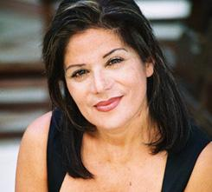

CHANTAL DENOUX
Producer, Actor, Writer,
Managing Director of Denoux Films Productions

Chantal Denoux travelled to disparate corners of the world while working as a reporter, journalist, psychologist, actor or producer.
She has won awards for her work as a songwriter, actor and producer.
Chantal Denoux hold a Master in Psychology and a Certificate in Media Studies.

As producer, she worked in France on animation programs and human rights short films.
In Australia, she produced a series 'Danger Zone', filmed in Hollywood and on the Gold Coast, 'My Home-Your War' filmed in Iraq and awards winner,
a series of hilarious animated dramas, 'Valise and Bloke', co-produced in India.
Chantal is currently developing a drama feature based on a true story In France and Australia. When Chantal is not producing or writing, she enjoys acting in Short Films, Feature Films or on Stage.

DENOUX FILMS PRODUCTIONS
Mob: +61 419808808
Tel : + 61 7 5510 9488
Fax: + 61 7 5510 9477
CD@denouxfilms.net
www. denouxfilms. net

Biography of Co- Producer: Marcus Gillezeau

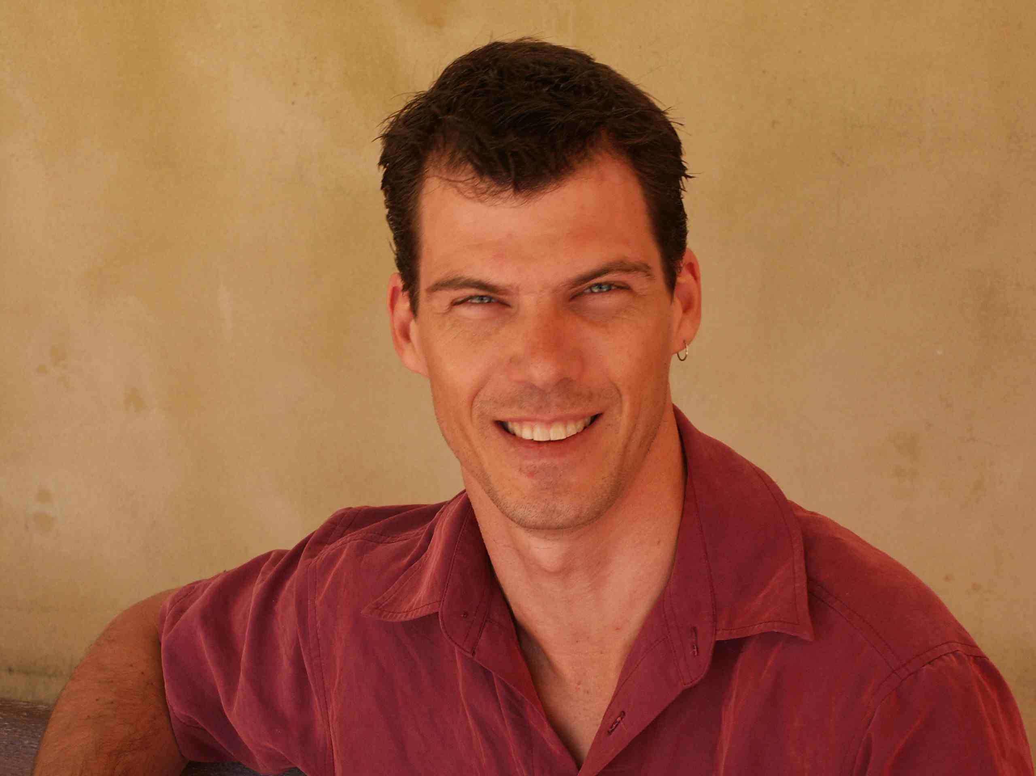
Marcus GILLEZEAU

Producer/Director
Managing Director of Firelight Productions


Marcus began his film career 20 years ago as a drama editor but was soon drawn to producing. The past five years have seen a focus on writing and directing and he continues to also shoot many of his films. Credits for the last two years cross several genres and include the four part series In the Line of Fire (Ch 9), Rock Eisteddfod Challenge (Ch 9), My Home, Your War (SBS), The Artist, The QC and The Refugee (ABC), Off the Record (World Movies) Snap Off the Lip (Fuel TV) and Skating on Thin Ice (Ch 9).

In 2002 he was the Executive Producer on the multi award winning documentary Painting with Light in a Dark World (SBS) and in 2001 he directed Little Dove - Big Voyage (Network 7), Australia’s first fully convergent, multi-platform documentary project. In 1998 he produced and co-wrote the adventure series Afrika - Cape Town to Cairo (ABC TV and National Geographic) that has subsequently sold in 32 countries.

He is a specialist in digital production technologies, writing the highly successful book Hands On - A guide to production and technologies for film, TV and new media and has been a principal in Firelight Productions with partner Ellenor Cox for the past ten years. Marcus is on the board of Metro Screen and is NSW Chapter Head for the Screen Producers Association. He has lectured at numerous institutions including AFTRS and Swinburn University and is a regular contributor to industry magazines.

FIRELIGHT PRODUCTIONS
6 Wills Avenue
Bronte
NSW 2024 Australia
Mob:+61 412 278 516
Tel: +61 2 9360 0007
marcus@firelight.com.au
www.firelight.com.au

Credits List (1)

OPEN FRAMES

Written and Directed by
KYLIE GREY

Executive Producer
CHANTAL DENOUX
DENOUX FILMS PRODUCTIONS

Producers
KYLIE GREY AND MARCUS GILLEZEAU

Editor
MATTHEW WALKER

Director of Photography
MAX BOURKE

Music and Sound design
BARTON STAGGS

ROLLER

Additional camera DAVID OPITZ

Additional sound JERRY RICKARD

Associate Producers MAX BOURKE AND DAVID OPITZ

Additional footage GEORGE GITTOES, CNN, ABC NEW YORK

Graphics KIM HOPWOOD, MICHAEL CREBAR AND TIM RIGG -
ADG CREATIVE AND MATTHEW WALKER

Titles KIM HOPWOOD AND TIM RIGG - ADG CREATIVE

Online MATTHEW WALKER AND FIRELIGHT PRODUCTIONS

Credits List (2)

Sound Mix MICHAEL GISSING

Script Editing BARTON STAGGS, MATTHEW
WALKER, JERRY RICKARD, LIZ DEEP-JONES,
CHANTAL DENOUX

Subtitles MATTHEW WALKER

Translators ALEX YOUSIF & DR MOHAMMED AL-NAKEEB,

Colour grade MATTHEW WALKER AND FIRELIGHT PRODUCTIONS

Thanks to
EDWARD BODKIN
JERRY RICKARD
EDWARD BODKIN (PILOT EDITOR)
LIZ DEEP-JONES
LEISA KELLAHER AND SHANE MUNRO
(LEGPIT PRODUCTIONS)
SARAH RUNCIE (AUSTRALIAN FILM COMMISSION)
ANNA MIRALIS (SBS TV)
DAVID HUCKER (SBS TV)
MATT CAMPBELL (SBS TV)
DAVID OPITZ AND METRO SCREEN STAFF
ALLAN GREY
PAT GREY
CRAIG AND DIANNE COUGHLAN (COGGO AUDIO/VISUAL PRODUCTIONS)
STEVEN TILEY AND RADIO NATIONAL STAFF
GUY, JONATHAN (FOUR CORNERS – ABC TV)
ELISE POTAKA
ELLENOR COX AND FIRELIGHT STAFF
TERESE ABBEY
MOHAMMED (DRIVER IN IRAQ PRE-WAR)
KARIM (MINDER IN IRAQ PRE-WAR)
NESCHWAN (DRIVER BAGHDAD)
KATRINA, HAZEL AND FUNG AT WEST STREET

Credits List (3)

Special thanks to

LAYLA, AMRO, YASIR, SHAIMA THEIR FAMILY AND FRIENDS IN IRAQ WHO HAVE RISKED THEIR LIVES TO TELL THEIR STORY FOR THIS FILM

CHANTAL DENOUX WHO SUPPORTED THE FILM WHEN NOBODY ELSE WOULD.

MY FAMILY AND FRIENDS WHO SUPPORTED ME SPIRITUALLY AND FINANCIALLY DURING THE COURSE OF THE THREE YEARS IT TOOK TO MAKE THIS FILM

CLOSE FRAMES

AUSTRALIAN GOVERNMENT LOGO | AUSTRALIAN FILM COMMISSION LOGO – Developed in association with the Australian Film Commission

FIRELIGHT LOGO DENOUX FILMS PRODUCTIONS LOGO

A FILM BY KYLIE GREY

COPYRIGHT SYMBOL – KYLIE GREY AND DENOUX FILMS PRODUCTIONS

Stills of the Film MY HOME –YOUR WAR

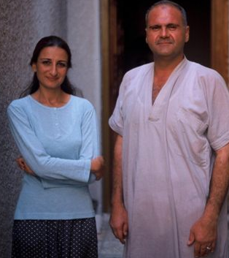 Layla and her husband, Yasir

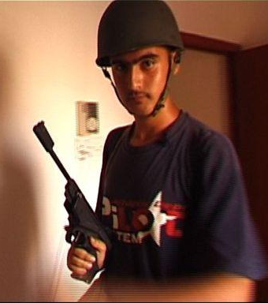

Amro, Layla and Yazir’s son

Stills of the Film MY HOME –YOUR WAR

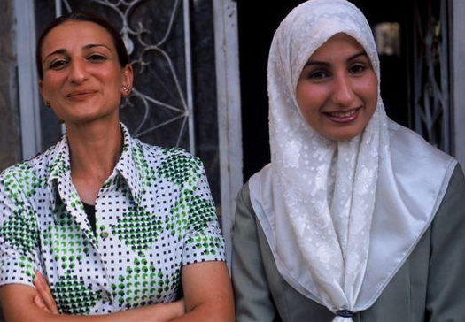

Layla and her sister, Shaima

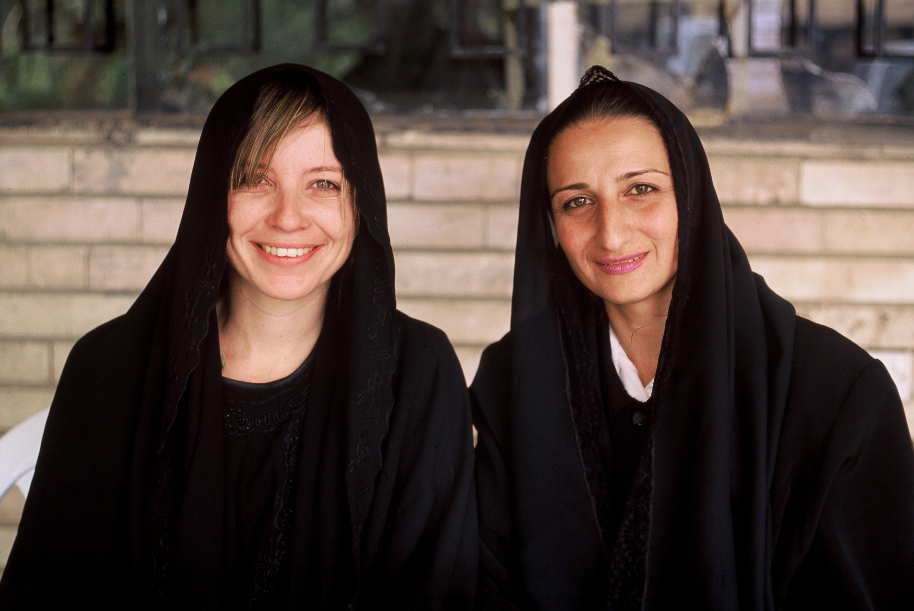

Kylie and Layla

Technical Features

Film Running : 52 min

Shooting format : DV cam

Projection Format : Beta SP PAL
- Master textless
- Master Texted /Subtitles English
- Master Texted

Sound: Dolby Digital

Primary contact: Executive Producer Chantal Denoux

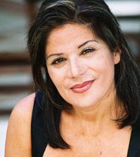
Chantal Denoux, Executive Producer
of the film My Home- Your War
DENOUX FILMS PRODUCTIONS
PO Box 1100 Paradise Pt
QLD 4216 Australia
Mob: +61 419808808
Tel : + 61 7 5510 9488
Fax: + 61 7 5510 9477
CD@denouxfilms.net
www. denouxfilms. net

